Date: 22/10/2024

|  |  |  |  |  |
| --- | --- | --- | --- | --- |
| **CE Declaration of Conformity**   |  |  | | --- | --- | |  | Machines SERDI, 23 avenue des Vieux Moulins-Annecy, France, declares being the manufacturer of the machine and its accessories:    Machine brand: **SERDI**  Machine description**: Valve seat and valve guide cutting machine**  Machine model: **S3.5**  Machine Serial number: … | | The following machine safety standards have been followed and applied according to the **Attestation of compliance** reference n°TRM-24-3127/01(Rev.01):   **EN ISO 12100 :2010 Safety of machinery** – General principles for design – Risk assessment and risk reduction   **EN ISO 60204-1 : 2018 – Safety of machinery** – Electrical equipment of machines – Part 1: General requirements | | |

Authorized by: .

# Mr. Jonathan Philips

General manager

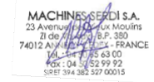

# MACHINES SERDI S.A

23, avenue des Vieux Moulins 74000 Annecy - FRANCE

**Note**: the declaration of conformity is issued under the sole responsibility of the manufacturer.

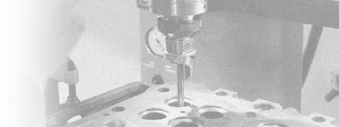

***DECLARATION OF  
CONFORMITY***

***MADE IN FRANCE***

***ADVICE &***

***SERVICE***

40

***YEARS AND MORE OF EXPERTISE***

WORLD CLASS TECHNOLOGY